**Lab Program: 06**

**Execute the fallowing queries:-**

**a. Retrieve the name of each employee controlled by department number 5(Use EXISTS Operator).**

**b. Retrieve the name of each dept and number of employees working in each department which has at least 2 employees.**

**Consider the Company database with following schema.**

**Step 1:-**

**DEPT (DNO: integer; DNAME: varchar; DLOCATION: varchar)**

**SQL> Create table DEPT**

**(DNO int (4) primary key,**

**DNAME varchar (20) Not Null,**

**DLOCATION varhcar (20));**

**Table created**

**Execution:-**

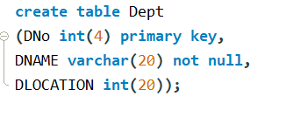

**SQL> Desc DEPT;**

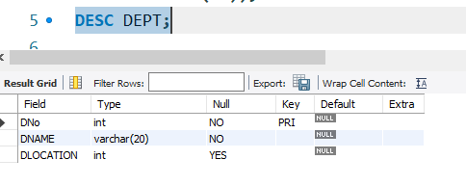

**Step 2:-**

**EMP (ENO: integer; ENAME: string; EBDATE: Date; ADDRESS: Text; GENDER: text; SALARY: int; DEPTNO: int)**

**SQL> Create table EMP**

**(ENO int (6) primary key,**

**ENAME varchar (20) Not Null,**

**EBDATE date,**

**ADRESS varchar (20),**

**GENDER char (3),**

**SALARY int (10) not null,**

**DNO int (4) references dept);**

**Table created**

**Execution:-**

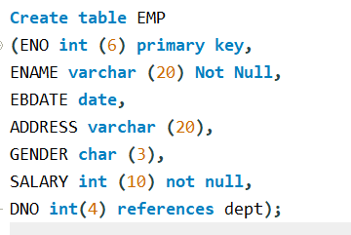

**SQL> Desc EMP;**

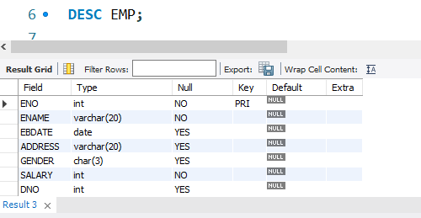

**Step 5:-**

**Insert into dept (DNO, DNAME, DLOCATION) values (2,’ACCOUNTS’, JAYANAGAR’);**

**1 rows created.**

**Insert into dept (DNO, DNAME, DLOCATION) values (4,’RESEARCH’, KENGERI’);**

**1 rows created.**

**INSERT INTO DEPT (DNO, DNAME, DLOCATION) values (5,'ADMIN','SOUTHEND');**

**1 rows created.**

**Execution:-**

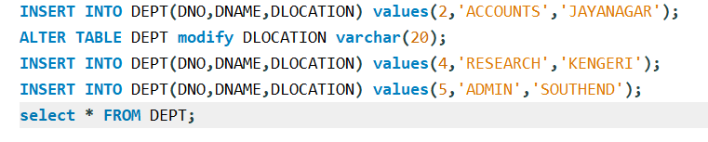

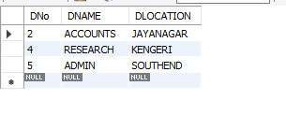

**Step 6:-**

**INSERT INTO EMP (ENO, ENAME, EBDATE,ADDRESS,GENDER,SALARY,DNO)**

**Values (1001,'ANIRUDH','1990-01-14','BANGALORE','M', 45000, 4);**

**Execution:-**

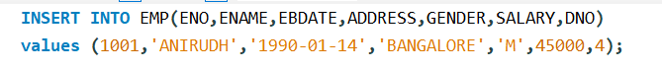

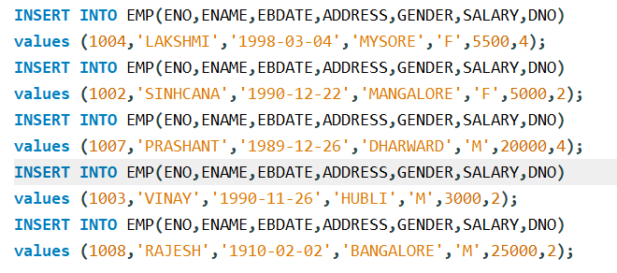

**Note: - Enter this values into the table EMP as shown below**

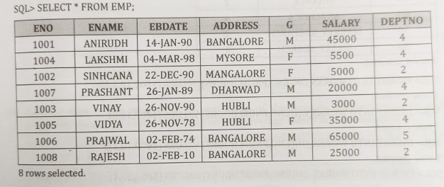

**Note: - Enter this values into the table EMP as shown below**

**Execute the Following Queries:**

1. **Retrieve the name of each employee controlled by department number 5 (Use EXISTS Operator).**

**SQL> select E.Ename from emp e**

**where exists(select D.DNo from dept d**

**where E.dno=D.dno and E.dno and E.dno=5);**

**Execution:-**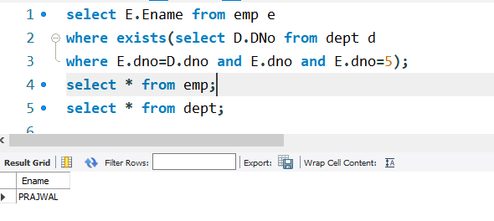

**Note:**

**EXISTS: The Exists operator is used to test for the existence of any record in a sub query. The Exists operator returns true if the sub query returns one or more records.**

**SQL EXISTS SYNTAX:-**

**Select column name**

**From table_name**

**Where Exists (select column name**

**From table_name**

**Where condition);**

**Ex 2:- Assignment of Exists operators**

**Create a table Product and insert the following records in the product table as shown below.**

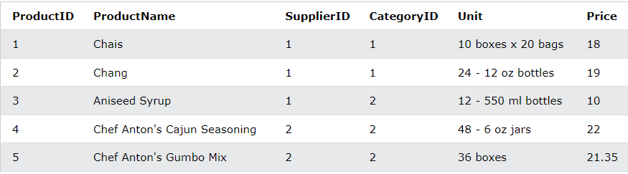

**Create a table suppliers and insert the following records in the suppliers table as shown below.**

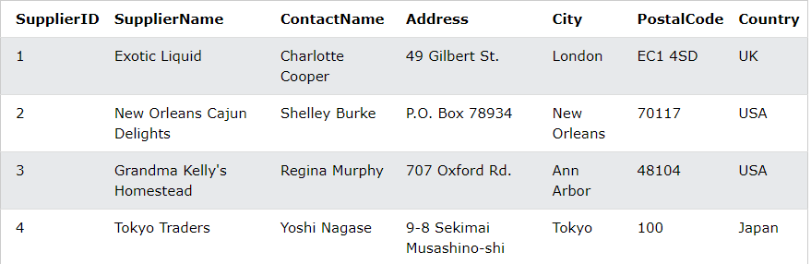

**Step 1:-**

**Select SupplierName**

**From Suppliers**

**Where Exist( select productName**

**From products**

**Where products.supplierID = Suppliers.SupplierID and Price < 20);**

**Step 2: -**

**Select SupplierName**

**From Suppliers**

**Where Exist( select productName**

**From products**

**Where products.supplierID = Suppliers.SupplierID and Price=22);**

**(b) Retrieve the name of each dept and number of employees working in each department which has at least 2 employees.**

**SQL>** **select D.DNAME,count (*) from EMP E,DEPT D**

**WHERE E.DNo=D.DNo group by D.DNAME HAVING COUNT(*)>2;**

**Execution:-**

